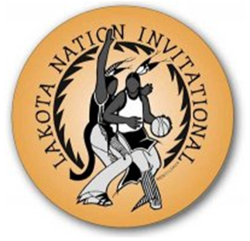
2022 Lakota Nation Invitational Art Show

INTENT TO PARTICIPATE

______ YES! Our school will participate in the 2022 LNI Art Show
______ NO. Our school will not participate in the 2022 LNI Art Show

School Name: ________________________________________________________________________________
School Address: ____________________________________________________________________________________________ ____________________________________________________________________________________________
Teacher Contact Name: ___________________________________________________________________________________
EMAIL ADDRESS: ___________________________________________
PLEASE HAVE SOMEONE PICK UP YOUR ARTWORK FROM YOUR SCHOOL ON SATURDAY EVENING AT 6:00PM OR SUNDAY MORNING
-WE HAVE BEEN TAKING BACK THE ART PIECES THAT WERE LEFT BEHIND SO THAT THEY WILL NOT END UP IN THE TRASH.

Teacher Phone (After Dec 14th) ___________________________________ __________________________________________
Alternate Contact: ________________________________________________________________________________________
(If teacher is not picking up the artwork on December 17TH)

Alternate Contact Phone: _______________________________________
Please FAX or Email this page no later than Friday, December 2, 2022
Lakota Nation Art Show Coordinators

MaDonna Crow Eagle, Coordinator Email: mcroweagle@sfisk12.org

Scott Fishel, Coordinator Email: utanatsutsa@gmail.com
Contact Info: MaDonna or Scott: 605-747-2297 FAX 605-747-2091

REGISTRATION FEE: $350.00 Make check payable to: LAKOTA NATION INVITATIONAL
Attn: Art Show
3213 West Main St. #425,
Rapid City, SD 57702

